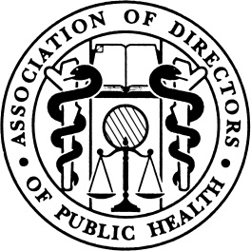

A conference for Directors of Public Health
02nd June 2015, Church House Conference Centre, Westminster, London

09:45 – 10:30 | Registration, refreshments and networking
10:30 – 10:45 | Welcome and introductions  Prof Dame Sally C. Davies, Chief Medical Officer  Dr Janet Atherton, President of the Association of Directors of Public Health
10:45 – 12:00 | Developing public health teams, leading public health locally
 | - Is current training fit for the future?
 |  | Health Education England speaker
 | - Facilitated discussion of training and workforce issues
 | - Distributed leadership and workforce development [includes discussion]
 |  | Prof Graeme Currie and Dr Brian Litchfield, Warwick University Business School
12:00 – 12:15 | Refreshments
12:15 – 13:15 | Getting people moving
 | - Physical activity and obesity [followed by discussion]
 |  | Prof Harry Rutter, Senior Clinical Research Fellow at the London School of Hygiene and Tropical Medicine, and Honorary Senior Clinical Lecturer, University of Oxford
 | - What is ‘parkrun’? (including Q&A)
 |  | Tom Williams, MD, parkrun and Ros Jervis, Director of Public Health, Wolverhampton
 | - Olympic and Paralympic legacy
 |  | Andrew Honeyman, Head of London 2012 Legacy and Physical Activity, DCMS
13:15 – 14:00 | Lunch and networking
14:00 – 14:30 | Post-election –bringing the public health agenda forward (at national and local levels)
 | - Facilitated discussion with senior public health stakeholders and attendees
14:30 – 15:45 | International issues
 | - Health protection systems - international comparisons
 |  | Dr Simon Howard, Public Health Registrar,
 | - Global health security, emergency preparedness and climate change
 |  | Prof Hugh Montgomery, Director of the UCL Institute for Human Health and Performance, University College London
 | - Ebola – national response and local planning
 |  | Dr Gina Radford, Deputy Chief Medical Officer
 | - Facilitated discussion of international issues including Ebola response
15:45 – 15:55 | Closing remarks from Prof Dame Sally C. Davies, Chief Medical Officer
15:50 - 16:15 | Networking opportunity, refreshments
Event jointly produced by the Association of Directors of Public Health and Department of Health

