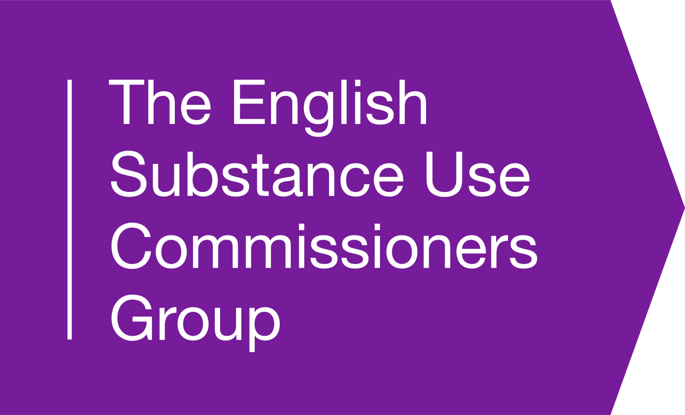 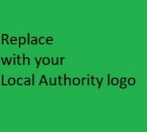 (You can move logos into the header if you wish)

Sent via Email
Name Your Name
Rank/Role Your Role
Police HQ Address LA/PH Team Address

Date

Dear Sir/Madam (delete as appropriate)

Re: Letter of Comfort Request / Distribution by drug services and all other community services which deliver harm reduction approaches to drug users of items designed to reduce drug related harm that are not specifically exempt from the provisions of The Misuse of Drugs Act, Section 9A, namely a pipe/safer inhalation kit for the purpose of smoking crack cocaine.

Section 9A of the Misuse of Drugs Act 1971 is a general prohibition on the supply of items to be used for the preparation or consumption of illicit drugs. However, the Act does include provisions to allow drug services to lawfully supply people who inject drugs with needles, syringes, pre-injection swabs, spoons, citric acid and ascorbic acid, filters, ampoules of water for injection, and foil. These are supplied to reduce the risk of transmission of blood borne viral infections, such as HIV and viral hepatitis amongst injecting drug user populations and the wider community. The list of exempt items has been extended several times in recent years to add items of paraphernalia that were previously illegal, with the express intention of removing the threat of prosecution from drug workers which enables them to safely undertake harm reduction programmes that have significant positive impacts on blood borne virus transmission rates. In addition to this there is emerging evidence that crack pipe/safer inhalation kit distribution can provide positive benefits in relation to drug services being able to effectively engage drug users in treatment programmes. Supply of crack pipes/safer inhalation kits by drug services also has substantial potential to help us reduce COVID-19 transmission.

The list of exempt items in Section 9a of the Misuse of Drugs Act 1971 is still not comprehensive, and the distribution of other items such as crack pipes/safer inhalation kits (to encourage crack users into contact with services, and to encourage them not to inject crack and/or other substances) is not yet exempt in law. Supply of crack pipes/safer inhalation kits by drug services has substantial potential to help us reduce drug related harm (particularly the harms related to crack injection), drug related litter, community concern, blood borne virus transmission; and COVID-19 transmission. There are high risks to individuals who chose to take controlled drugs, and intravenous drug use carries with it high risks of infection, overdose and of a spiral into decline which is often linked to more serious forms of criminality.

We understand that POLICE FORCE cannot condone the illegal use of controlled substances, but we hope that you are able to support community initiatives, delivered by partner agencies which are intended to reduce the harm caused by illegal drug use. We request that POLICE FORCE, not actively seek to enforce any legislation regarding the supply of crack pipes/safer inhalation kits to people as part of structured drug treatment. We understand and would undertake measures to ensure that it can be satisfied in each instance that the supply has been made in the best interests of that client in an attempt to engage them and reduce the harm caused by their intravenous drug use and that the supply is in the context of a drug treatment plan (within the meaning of Regulation 6A(4) of the Misuse of Drugs Regulations 2001).

Should you grant a letter of comfort, the provision of crack pipes/safer inhalation kits will be undertaken by people employed/engaged by local authority commissioned services, who are contracted to undertake the lawful provision of drug treatment services. In this instance we would seek for staff off NAME SERVICE/SERVICES HERE to be able to provide crack pipes/safer inhalation kits as part of engagement in and provision of treatment services for people who use crack cocaine.

Finally, we would like to state that:

- We are aware that the provision of pipe kits remains a breach of section 9a of the Misuse of Drugs Act.
- POLICE FORCE cannot condone the illegal use of controlled substances.
- For the duration of this agreement breaches of section 9a of the Misuse of Drugs Act by drug services for the purpose of providing pipe kits will not be investigated by POLICE FORCE and as a result will not be brought to the attention of the CPS.
- We will seek to implement a specific performance management framework to ensure that the provision of pipe kits is appropriately monitored and is fit for purpose.
- POLICE FORCE may reserve the right to revoke this agreement unilaterally with immediate effect but would inform us in advance of any decision.
- Continuation to provide pipe kits to service users after termination of this agreement may expose services to prosecution for being in breach of section 9a of the Misuse of Drugs Act.

Thank you for your time and consideration regarding this request. Please do not hesitate to contact me should you wish to engage in discussion prior to any decision being made.

Yours faithfully,

Name
Role

Effectiveness of needle and syringe Programmes in people who inject drugs – An overview of systematic reviews | BMC Public Health | Full Text (biomedcentral.com)
The SIPP (Safe Inhalation Pipe Provision) study | LSHTM
An urgent impetus for action: safe inhalation interventions to reduce COVID-19 transmission and fatality risk among people who smoke crack cocaine in the United Kingdom - PMC (nih.gov)

