Time limited MenB vaccination offer 2026
Communications toolkit for stakeholders

Contents

Introduction 3

Help up spread awareness of the limited time offer this summer 3

About MenB and the vaccine 4

Signs and symptoms of meningitis and sepsis 4

MenB vaccination programme 2026 for England 6

Information on the offer in the developed nations and Crown Dependencies 7

Key messages 7

Communications assets and suggested social media copy 9

MenB consent and promotion publications 9

Other useful resources 16

Suggested copy for stakeholder publications 16

UKHSA quotes for stakeholder communications 17

Statistics 18

FAQ 18

About the UK Health Security Agency 25

Introduction
The UK Health Security Agency (UKHSA), NHS England & Department of Health and Social Care (DHSC) are working with partners on the rollout of the time limited offer of the MenB vaccine for eligible young people for 2026.
This toolkit, produced jointly by UKHSA & NHS England, contains background information, social media assets and suggested copy, FAQ and other useful information to help support stakeholders promote the offer to eligible young people across the summer.
The information provided is correct as of July 2026.
For further information about our national communications please contact: externalaffairs@ukhsa.gov.uk.
Sign up to our Stakeholder Cascade to receive a weekly newsletter with the latest news, updates and guidance from UKHSA.
Follow UKHSA on X: @UKHSA, BlueSky: @ukhsa.bsky.social and Instagram: @ukhsa
Follow NHS England on X: @NHSEngland and Instagram: @nhsengland.
Visit UKHSA’s website at GOV.UK.

Help up spread awareness of the limited time offer this summer
There are a number of ways that stakeholders can help us to communicate the benefits of getting the MenB vaccine to those eligible:
- Share information with your networks – we have a wide variety of resources available in this toolkit tailored for your audiences. This includes key messages, social media assets, suggested stakeholder copy and FAQ to help answer any questions you may get from your networks. You can also help amplify any UKHSA, Department of Health & Social Care and NHS communications on the offer via resharing relevant posts on our social media channels.
- Contact us if you would like to do something more bespoke – if you are looking to do something special to promote the importance of taking up the MenB offer on your social media or website, or would like some creative input on any other communications plans you may have, please email us to see how we might be able to support.
- Email us about using our spokespeople – if you are planning a webinar or briefing for your audiences and would like one of our senior clinicians to speak about meningitis and the importance of getting the vaccine, please get in touch via email.
To discuss any of the above or any other suggestions you may have, please email externalaffairs@ukhsa.gov.uk.

About MenB and the vaccine
Meningococcal group B (MenB) bacteria can cause serious, life-threatening illnesses including meningitis (inflammation of the lining of the brain) and sepsis (blood poisoning). These conditions can lead to life-changing disabilities such as amputations, hearing loss, brain damage and scars, and sadly in some cases, death.
The bacteria that cause MenB disease can be spread through close contact with a person who has them. This can be through kissing or sharing drinks or vapes or close contact with the person for long periods of time, such as living in the same home.
The speed and size of the MenB outbreak in Kent earlier this year was exceptional. There have also been more clusters than normal this year, some of which have been bigger than expected. This means there is some uncertainty about the level of risk MenB could pose for young people this year, and along with partners, we are undertaking further work to better understand whether the clinical risk has changed.
We do know that being around lots of new people in shared living spaces makes it easier for the bacteria that cause meningococcal disease to spread, and we know that starting university puts young people at increased risk.
This one-off vaccination programme will help to protect those at highest immediate risk. On 16 July 2026, published its recommendation and additional considerations to Government on a routine MenB programme for adolescents. This will now be considered by Government to determine if any additional offer of MenB vaccine should be made.
Getting vaccinated before the autumn term is one of the most important things young people can do to protect themselves.
Young people in the eligible groups will have been offered MenACWY vaccine in year 9 or year 10. This vaccine protects against other kinds of meningococcal bacteria but will not help protect against MenB disease. So, even if someone has already received the MenACWY vaccine, getting the MenB vaccine is important.

Signs and symptoms of meningitis and sepsis
The introduction of the one-off programme presents an opportunity for stakeholders to make their audience aware of the signs and symptoms of meningitis and sepsis. No vaccine is 100% effective, so it will be important to communicate this messaging alongside promoting the offer.
Initially meningococcal disease (which can cause meningitis and sepsis) can be like a bad case of flu. But anyone affected will usually become seriously ill within a few hours. It is important to be aware of signs and symptoms as early treatment can save lives.
Symptoms such as a rash of blotches that doesn’t fade (do the glass test), being confused or delirious, or too sleepy to wake occur later and are very serious – if you see these symptoms seek help immediately.
For meningitis, the most important signs to look out for are:
- fever
- a very bad headache
- vomiting
- stiff neck
- dislike of bright lights
- confusion, delirium
- severe sleepiness, losing consciousness
- seizures
- rash
For sepsis, the most important signs to look out for are:
- fever and shivering
- severe pains and aches in limbs and joints
- vomiting
- very cold hands and feet
- pale or blotchy skin
- rapid breathing
- diarrhoea and stomach cramps
- red or purple ‘bruised’ or blotchy rash on skin that do not fade under pressure – do the glass test. On dark skin, check inside the eyelids or roof of the mouth where the spots may be more visible
- difficulty walking or standing
- severe sleepiness, losing consciousness
If you or someone you know becomes unwell and are worried about meningitis or sepsis, seek medical help urgently by going to the nearest Accident and Emergency department or calling 999. If a friend goes to bed unwell, check on them regularly. Early treatment can be lifesaving.
For more information on meningitis please visit The Meningitis Research Foundation and Meningitis Now websites.

MenB vaccination programme 2026 for England
On Friday 12 June, Department of Health and Social Care (DHSC) announced that there would be a one-off vaccination programme launching ahead of the 2026 academic year, with the vaccine being offered to:
- Everyone born between 01/09/2007 and 31/08/2008
- Young people under 25 (born on or after 21/07/2001) who will be starting higher education for the first time, or who will be starting further education for the first time as a residential student, in autumn 2026
- International students under 25 entering their first year of university should receive their first dose in their home country where possible to give the best chance of protection ahead of the start of the autumn term
Eligible people will need two doses for protection, with the first being offered from July and the second dose provided from August. All those who are eligible for the MenB vaccine can continue to get first doses until 31 December 2026; they can get their second dose up to 31 March 2027.
In England, vaccines will be available at community pharmacies. The programme starts from 20 July 2026, giving eligible people time to complete both doses before cases typically rise in the autumn.
- Those born between 01/09/2007 and 31/08/2008 will be contacted by the NHS and sent a link through which they can book a pharmacy appointment to get the vaccine.
- University and residential further education students who are eligible can find a pharmacy offering MenB using the NHS website.
The National Booking System for eligible people in England went live on 13 July: Book a MenB vaccination appointment - NHS
Anyone who is eligible is encouraged to get both doses of the vaccine as soon as they can (noting that a minimum interval of 28 days is required between the two doses).

Information on the offer in the developed nations and Crown Dependencies
Each devolved nation (Scotland, Wales & Northern Ireland) and Crown Dependencies will manage their own one-off vaccination programmes:
Wales
To find out more about eligibility and how to make your booking:
- MenB vaccine for young people (Public Health Wales)
- MenB vaccination: list of eligible residential further education settings for older children and young adults
Scotland
Eligibility and booking:
- Vaccines for students (NHS inform)
- Meningococcal B (MenB) vaccine for young people (NHS inform)
Northern Ireland
The Public Health Agency (PHA) will also be updating content relating to Meningitis and student life (contains info for other adolescent vaccines) and they can be found on ni -direct and on the PHA website:
- Urgent MenB vaccination programme for adolescents and young people

If you are a stakeholder who needs information on how the rollout will work in the devolved nations, we recommend contacting the relevant public health agency directly. Information in this toolkit focusses on the England-wide one-off programme unless stated otherwise.

Key messages
- Hundreds of thousands of young people across England can get protection against meningococcal B disease (MenB) through a one-off vaccination programme launching ahead of the 2026 academic year.
- You are eligible for the free two-dose MenB vaccine if:
  - You were born between 01/09/2007 and 31/08/2008)
  - You were born on or after 21/07/2001 and will be starting university for the first time in autumn 2026
  - You were born on or after 21/07/2001 and will be starting further education for the first time as a residential student this autumn
- Two doses of the MenB vaccine are essential for protection and you need to get your second dose at least 28 days after your first dose.
- You can get your first dose of the MenB vaccine in a community pharmacy near you from late July 2026.
- International students born on after 21/07/2001 entering their first year of university, should be vaccinated in their home country where possible, to ensure there is time to get protected before starting their studies.
- The MenB vaccine helps protect against most strains of meningococcal group B bacteria that can cause serious illnesses, including meningitis and septicaemia.
- Book your vaccine at a pharmacy near you today.
- Being around lots of new people in shared living spaces like university halls makes it easier for the bacteria that cause meningococcal disease to spread, so it’s important you get vaccinated before you go, to help protect yourself.
- It’s important to recognise the signs and symptoms of meningitis and sepsis. Symptoms of meningitis can include a fever, headache, rapid breathing, drowsiness, shivering, vomiting and cold hands and feet. Sepsis can also cause a characteristic rash that does not fade when pressed against a glass.
- If you or someone you know becomes unwell and are worried about meningitis or sepsis, seek medical help urgently by going to the nearest Accident and Emergency department or calling 999. If a friend goes to bed unwell, check on them regularly. Early treatment can be lifesaving.

Communications assets
Some communications assets, including social media assets, posters, digital screens and web banners are already available on the Campaign Resource Centre.
Further communications assets will be uploaded in the coming days, and this toolkit will be updated with these new materials.

MenB consent and promotion publications
The following resources which can be used across various settings can be downloaded or ordered for free via the Find public health resources website.
If you a health professional or work for a local authority, and have registered on the website, you can order up to 500 – 1000 copies as long as you are logged in. If you are a member of the public, you will be able to order up to five copies. If you are having any trouble ordering, please email publichealthresources@ukhsa.gov.uk.

Assets to download or order | Description
The signs and symptoms of meningitis and septicaemia - digital screens  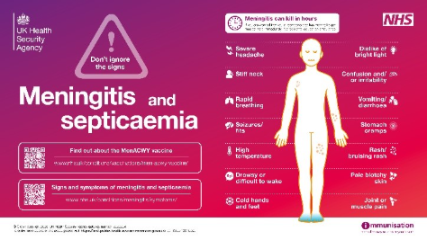 | How to use  These graphics should be used on digital display screens to notify the public of the signs and symptoms of meningitis and septicaemia. For posters displaying this information for use on noticeboards and where digital displays are unavailable please see product code: IM23DISP1  Who it's for  - General public  - GP surgeries  - Headteachers and supporting staff  - Secondary school  - Young adults
Meningitis: Don't ignore the signs and symptoms posters  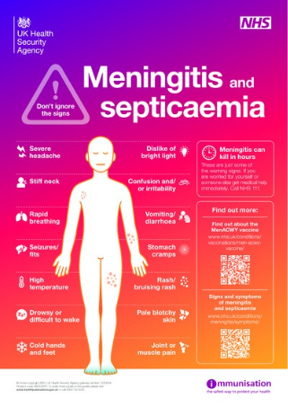 | This poster describes the warning signs of meningitis, so that teenagers and young people, know what to look out for if they or someone they know falls ill.  It should be displayed in common areas, in areas such as university halls, college common rooms, classrooms and meeting places as well as appropriate healthcare settings.  Who it's for  - GP surgeries  - Health professionals  - Secondary school  - Young adults  Product code: IM23DISP1
A guide to the Meningococcal B vaccines that protect against meningitis and septicaemia leaflet  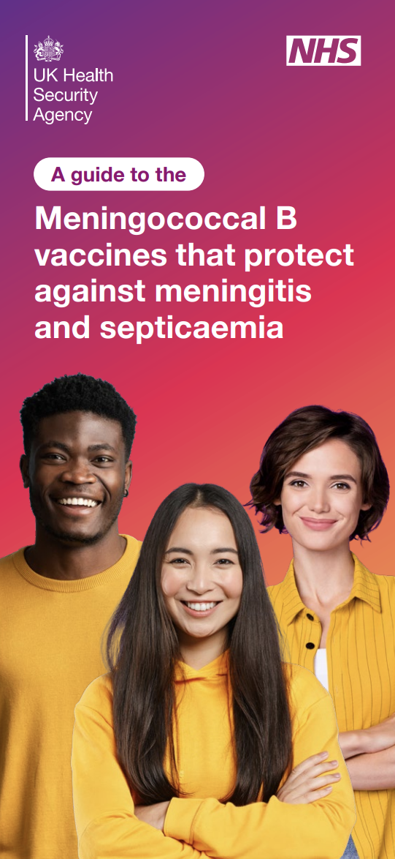 | How to use  This guide to the MenB vaccinations to protect against meningitis and septicaemia should be given to anyone eligible for a vaccination. The vaccines are offered to close contacts and anyone in the risk group. There is also a Men B vaccination record card, consent form and quick guide available to order.  Who it's for  - Young adults  Product code:1 3347 EN 001
MenB vaccination poster  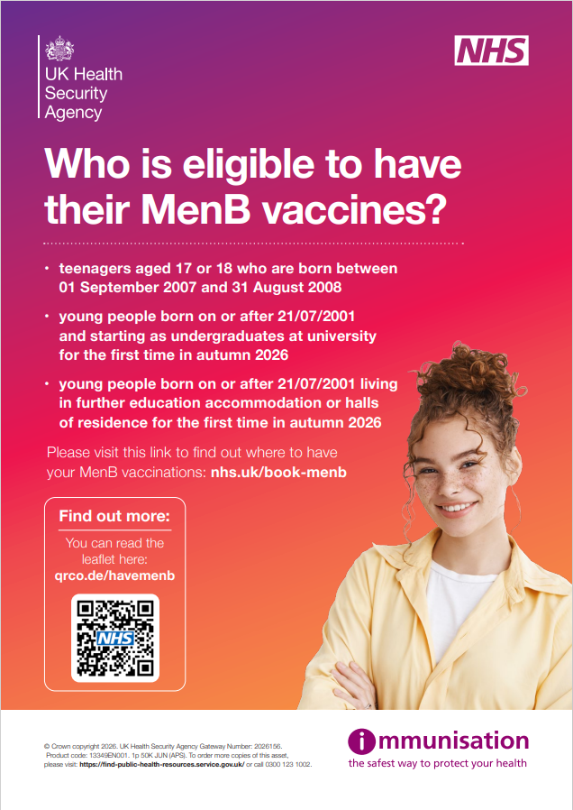 | How to use  This poster should be displayed in any service offering the MenB vaccination to eligible young adults. It is suitable for pharmacies, GP practices on University campus and all primary care settings offering the MenB vaccination.  Who it's for  - Young adults  Product code: 1 3349 EN 001
MenB vaccines record card  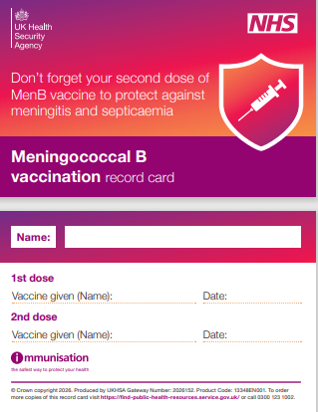 | How to use  This record card should be given to anyone who has received one dose of MenB vaccine to remind them to attend the clinic for their second dose of vaccine to complete the course. Each pack contains 25 cards.  Who it's for  - GP surgeries  - Health professionals  - Young adults  Product code: 1 3344 EN 001
Consent form  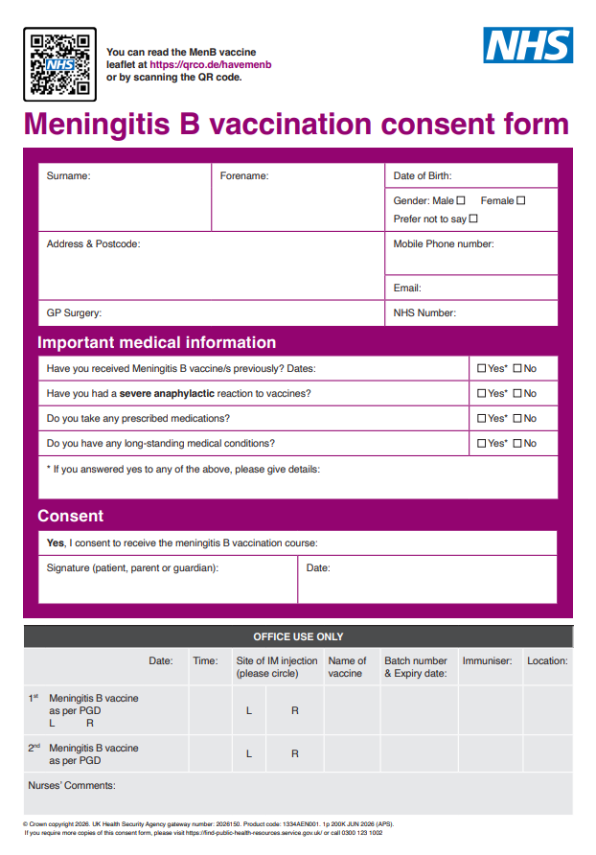 | How to use  The MenB vaccination consent form can be used to record every MenB vaccination given. It can be used for vaccination pop up clinics and off site vaccination. It is for health professionals and can be ordered with record cards, leaflets and posters to help the administration of either of the MenB vaccines, Bexero or Trumenba.  Who it's for  - Secondary school  - Young adults  Product code: 1 334A EN 001
MenB pharmacy and GP practice digital display posters – Are you eligible?  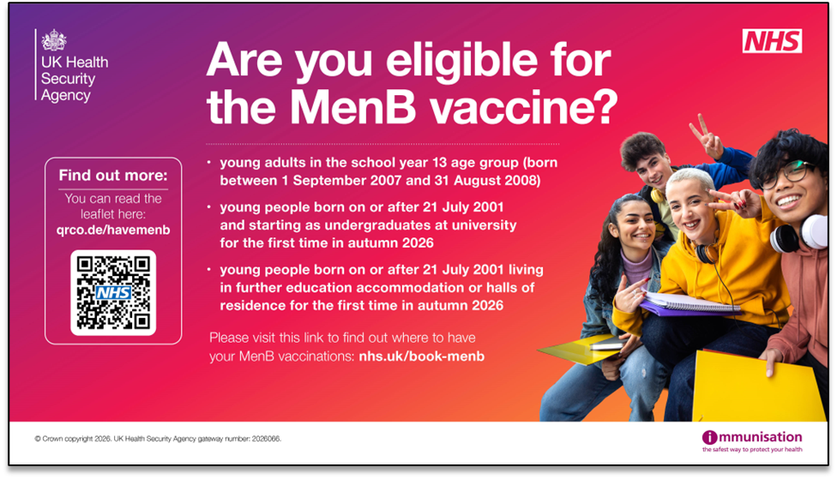  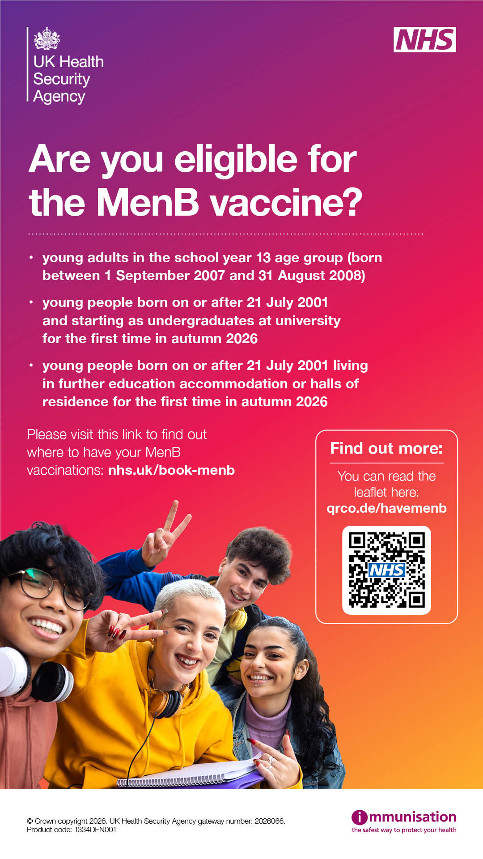 | How to use  These digital display files can be downloaded and then used on screens to promote the vaccination offer. The QR code shows the patient leaflet as above. –  Landscape: 1334CEN001  Portrait: 1334DEN001
MenB pharmacy and GP practice digital display posters  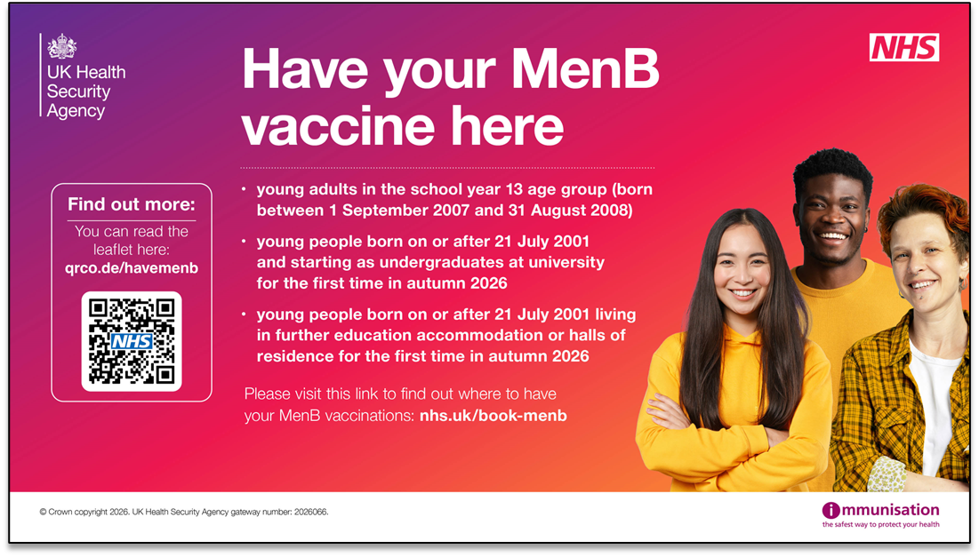  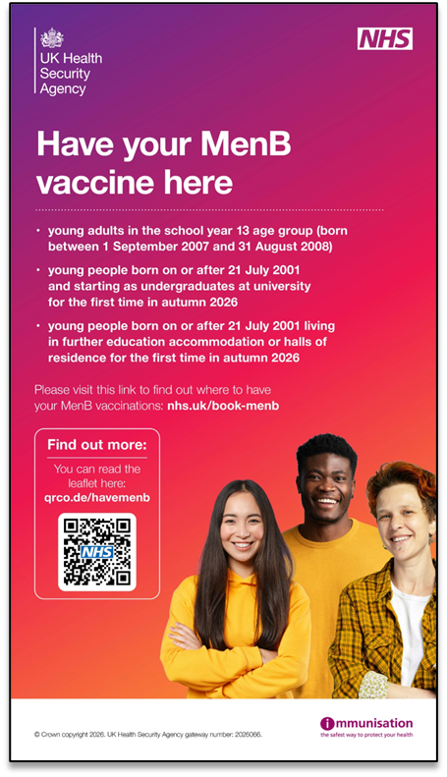 | How to use  These digital display posters can be used on screens in pharmacies offering the vaccination and on site at vaccination clinics or pop up clinics. The QR code shows the patient leaflet as above.  ·‘Have your vaccine here - digital posters to download here:  -Landscape: 1334FEN001  -Portrait: 1334EEN001
MenB pharmacy and GP practice digital display posters – who is eligible  Landscape: 1334GEN001  Portrait: 1334HEN001  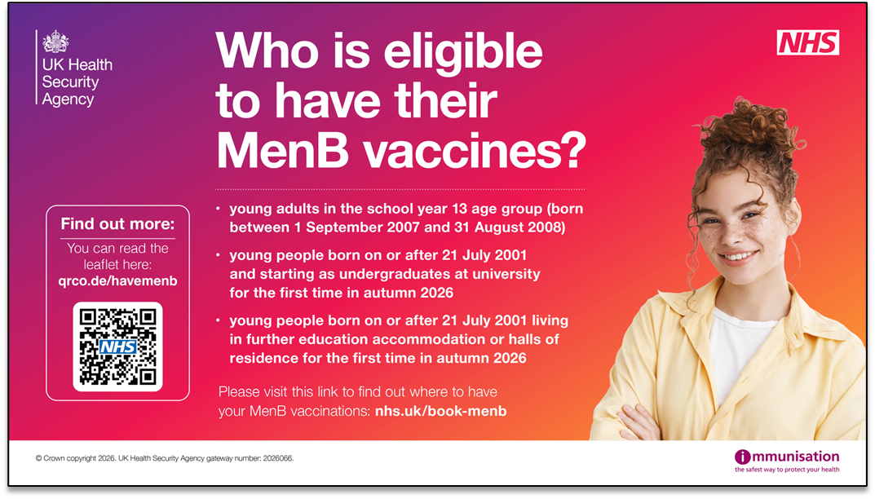  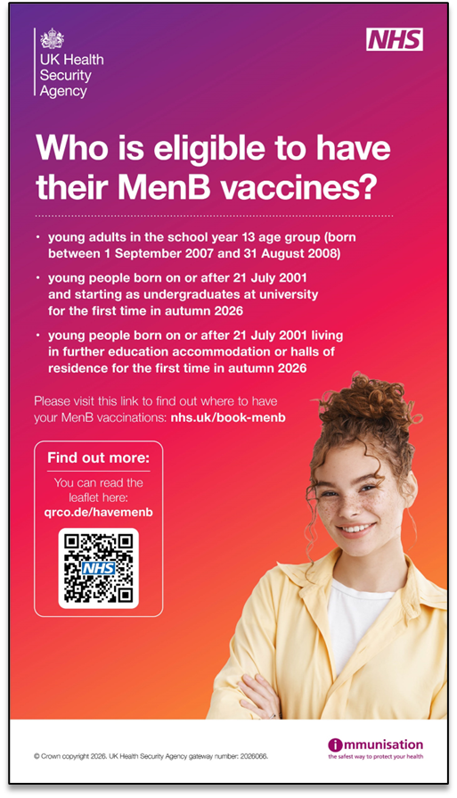 | How to use  These digital display files can be downloaded and then used on screens to promote the eligibility criteria to young adults
MenB web banners and email signatures  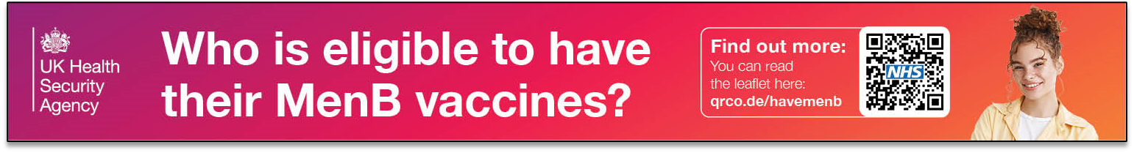  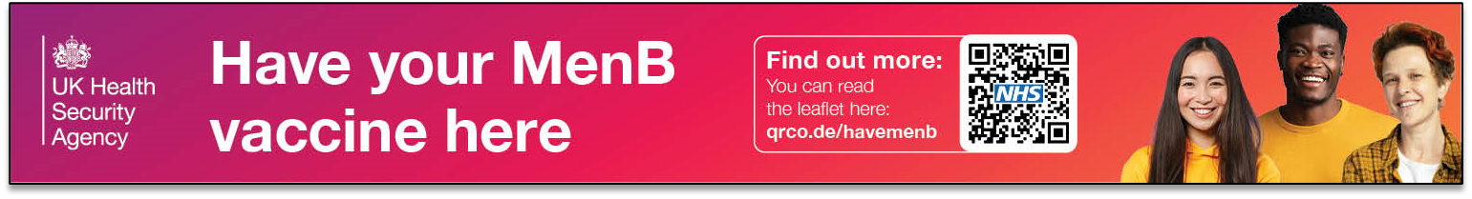  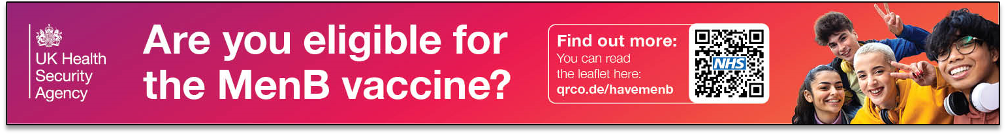 | How to use  This is a set of three files which can be used as email signatures and website banners to promote the limited MenB offer and where to have the Menb vaccinations for young adults.  Three designs of MenB web banners to use on websites or email signatures  Product code:  1334NEN001
MenACWY Save a Life wall sticker  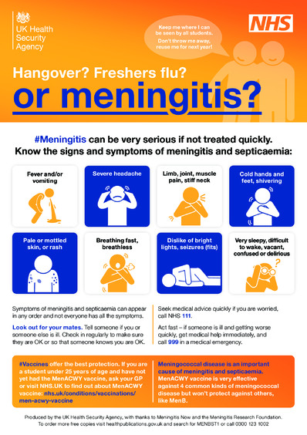 | How to use  This is the 'Save a life' microadhesive sticker for universities, residential colleges and further education including halls of residence and private shared accommodation for students. It is to raise awareness of the signs and symptoms of meningococcal disease and the need for students under 25 to have their MenACWY vaccine. You can download the QR code version of the sticker below or use the link, and encourage all students to bookmark this link on their smart phones: https://qrco.de/menacwys NB please also order actual stickers that don't rely on students having their phone and are visible in all accommodation.  Product code: MENBST1  Other language versions for international students  Arabic version product code: MENBST1AR  Bengali version product code: MENBST1BN  Chinese (simplified) product code: MENBST1CHS  Chinese (Traditional) product code: MENBST1CHT  Gujarati version product code: MENBST1GU  Hindi version product code: MENBST1HI  Japanese version product code: MENBST1JA  Korean version product code: MENBST1KO  Urdu version product code:  MENBST1UR

Other useful resources
UKHSA blog
- Who is eligible for the new one-off MenB vaccine programme?
- What is meningitis? Symptoms, risks and how to protect yourself
Press releases
- Thousands of young people to be offered 2-dose MenB vaccine
- NHS England » Young people urged to book lifesaving meningitis jab at high street pharmacies
NHS information pages
- Book a MenB vaccination appointment - NHS
- Meningitis - NHS
- Sepsis - NHS

Third sector resources
- Both The Meningitis Research Foundation and Meningitis Now websites contain helpful information on meningitis
- The UK Sepsis Trust also provides information on sepsis.
Information for health professionals
- Guidance for public health management of meningococcal disease in the UK
- A guide to the Meningococcal B vaccine that protects against meningitis and septicaemia
- UKHSA/NHS England MenB Vaccination Webinar for Community Pharmacies
- Communications toolkit for primary care settings

Suggested copy for stakeholder publications
You may wish to use the below text or use as a template to help promote the offer on your website, newsletter or any other public facing communications. The below is for the England offer, but can be adapted for the devolved nations:
Protect yourself against meningitis – get your free MenB vaccine
A free, time-limited vaccination programme is launching across England and the devolved nations to protect young people against meningococcal B (MenB) disease, which can cause life-threatening meningitis and sepsis.
You are eligible if you are:
- In England and Wales and born between 01/09/2007 and 31/08/2008 (current 2025/26 school year 13)
- A young person under 25 (born on or after 21/07/2001) who will be starting higher education for the first time, or who will be starting further education for the first time as a residential student, in autumn 2026.
Being around lots of new people in shared living spaces makes it easier for the bacteria that cause meningococcal disease to spread, and we know that starting university puts you at increased risk. Getting vaccinated before you go helps protect you and those around you.
What you need to know:
- Two doses are required for protection, at least 28 days apart
- Your first dose will be available at community pharmacies in England from 20th July 2026
- International students should aim to get their vaccinations in their home country where possible to get the best protection before starting their studies
[PLACEHOLDER – activate from 13 July] Book your free vaccine at a pharmacy near you today at [insert booking link].

UKHSA quotes for stakeholder communications
You may wish to use the below quote from one of our clinicians in your own communications to help promote the offer to your audience:
Dr Shamez Ladhani, consultant epidemiologist at UKHSA, said:
“While MenB outbreaks are uncommon, when they occur, they can be devastating as recent outbreaks have sadly shown.
“The risk is higher among young people starting university where close and prolonged contact with lots of new people increases the chances of being exposed to the meningococcal bacteria. Two doses of the MenB vaccine is essential and will give good protection against most strains and help to give young people and their families some reassurance.”
Caroline Temmink, Director of Vaccination at NHS England, said:
“The NHS is ready to deliver this vital vaccination programme with appointments available at a number of community pharmacies from the end of July ahead of students starting university.
“Those eligible will be contacted directly through the NHS App, by text and email and for those under 25 starting university for the first time they will be able to book their appointment directly with available pharmacies.
“Meningitis can be life-threatening and we urge everyone eligible to book appointments for their MenB vaccines soon as bookings open in mid July and to get both doses to ensure maximum protection.”

Statistics
- The MenB vaccine has an established safety record and is already offered routinely to infants through the NHS childhood vaccination programme. Evidence from the UK infant vaccination programme shows that vaccination has led to around a 75% reduction in MenB disease among eligible vaccinated groups.

- UKHSA data shows there were 313 confirmed cases of MenB in England during 2024 to 2025, which accounts for approximately 83% of all invasive meningococcal disease (IMD) cases, disproportionately affecting young adults and teenagers, as well as infants who are already offered the vaccine through the NHS vaccination schedule.

- The MenB outbreak in Kent in March 2026 led to 21 confirmed cases, with 2 deaths.

FAQ

Eligibility

Who is eligible?
- Everyone in England and Wales born between 01/09/2007 and 31/08/2008 (school year 13 in 2025/26)
- Everyone in Scotland born between 01/03/2008 and 28/02/2009 and others who are part of the current school year S6 2025/26
- Everyone in Northern Ireland born between 02/07/2007 and 01/07/2008 (current school year 14 2025/26).
- Young people born on or after 21/07/2001 who will be starting higher education for the first time, or who will be starting further education as a residential student for the first time, in Autumn 2026. This includes international students and students in the UK Devolved Administrations and Crown Dependencies.

Who isn’t eligible?
- Young people born on or after 21/07/2001 who are not attending higher education, or starting further education as a residential student, for the first time in Autumn 2026.
- Postgraduate students, as they aren’t entering higher education or residential further education for the first time in Autumn 2026.
- Anyone who has completed a 2 dose course of Bexsero®, a 2 dose course of Trumenba® (with the doses given at least 6 months apart) or a 3 dose course of Trumenba® within the last 5 years.

Why isn’t this programme being offered to all young people?
This is a time-limited offer of vaccination for those at highest risk. On 16 July, Joint Committee on Vaccination and Immunisation (JCVI) published its recommendation and additional considerations to Government on a routine MenB programme for adolescents. This will now be considered by Government to determine if any additional offer of MenB vaccine should be made.
Data on invasive meningococcal disease over the last 5 years has shown the highest number of cases, after infancy, are seen in 18- to 19-year-olds. Students in their first year of university have a risk that is about 7 times higher than that of young people of a similar age who do not go to university. Among university students, the evidence is that risk is highest among those living in catered halls of residence.
It is important that anyone going to university or further education that is eligible gets both doses of the MenB vaccine, wherever possible, before they leave home to start their university or further education course.

What about gap year students?
Gap year students are eligible if they were born on or after 21/07/2001 and are entering higher education or will be living at residential further education for the first time in Autumn 2026.

What about international students?
Eligible international students can get the vaccine free of charge regardless of their nationality or immigration status.
Two doses of the vaccine are essential for protection so, to ensure as many young people as possible are protected before the Autumn term, international students are advised to seek the first dose of the MenB vaccination in the country they’re currently in, and before they travel to the UK, where possible.

What about boarding schools?
Boarding school students are only eligible in England if born between 01/09/2007 and 31/08/2008 (school year 13 2025/26).
Other students aren’t eligible because they don’t tend to have the same mixing patterns as young people of their age attending higher or residential further education and are therefore not at the same level of risk.

What about young people in detained setting such as young offenders institutes?
Young people in detained settings such as young offenders institutes are only eligible in England if born between 01/09/2007 and 31/08/2008 (current school year 13 2025/26)
All other young people in detained settings aren’t eligible because they don’t have the same mixing patterns as young people of their age attending higher or residential further education.

What about those living in migrant accommodation?
Young people living in migrant accommodation are only eligible in England if born between 01/09/2007 and 31/08/2008 (school year 13 2025/26). All other young people in migrant accommodation aren’t eligible because they don’t tend to have the same mixing patterns as young people of their age attending higher or residential further education.

Operational delivery (England only)

Where and when can people get vaccinated?
In England, vaccines will be available at community pharmacies, with the booking system going live on 13 July.
The programme starts from 20 July 2026 in England, giving eligible people time to complete both doses before cases typically rise in the autumn.
All those born between 01.09.2007 and 31.08.2008 will be contacted by the NHS and sent a link through which they can book a pharmacy appointment to get the vaccine. Other university and residential further education students who are not born between 01.09.2007 and 31.08.2008 and are eligible can book their vaccine directly at a participating community pharmacy. For a list of all pharmacies offering MenB use the NHS website.
Anyone who is eligible is encouraged to get both doses of the vaccine as soon as they can (noting that a minimum interval of 28 days is required between the two doses).
Individuals should also make sure they are up to date with other vaccines they may be still eligible for including MenACWY, MMR, HPV and catch up at their GP practice. All those who are eligible for the MenB vaccine can continue to get first doses until 31 December 2026; they can get their second dose up to 31 March 2027.

Do people need to book an appointment?
Those born between 01.09.2007 and 31.08.2008 will be invited e to book an appointment through the National Booking Service. Other eligible people will be able to access vaccination via a walk-in appointment at participating pharmacies.

What if people miss out on getting vaccinated before September term starts?
We recommend that people get vaccinated as soon as they can after 20 July so that they’re able to have both doses, and build protection, before Autumn. Two doses are needed for the best protection. The second dose should be given at least 28 days after the first, and it then takes a further 2 weeks for the body to build immunity.
If someone can’t get vaccinated before the autumn term starts, they will still be able to get their first dose until 31 December 2026 and their second dose until 31 March 2027.

What if people are relocating to another UK nation before they have their second dose?
Those eligible can get their first and second dose of the vaccine in any of the four nations. Note that where you get the vaccine may differ depending on which area you are moving to.
In England, the vaccines will be offered in community pharmacies, with variation in delivery models across the devolved UK nations.

The vaccine

What is MenB and why get vaccinated?
Meningococcal group B (MenB) bacteria can cause serious, life-threatening illnesses including meningitis and sepsis. Being around lots of new people in shared living spaces makes it easier for the bacteria that cause meningococcal disease to spread, and we know that starting university puts young people at increased risk. Getting vaccinated before the autumn term is one of the most important things young people can do to protect themselves.
Young people in the eligible groups will have been offered MenACWY vaccine in year 9 or year 10. This vaccine protects against other kinds of meningococcal bacteria but will not help protect against MenB disease. So, even if someone has already received the MenACWY vaccine, getting the MenB vaccine is important.

What MenB vaccine will be used for the programme?
The vaccine Bexsero ®, manufactured by GSK, will be used for this programme. This is the same vaccine that’s been used in the MenB infant programme since 2015.

How many doses are needed and when?
Two doses are needed for protection. The second dose should be given at least 28 days after the first, and it then takes a further 2 weeks for the body to build immunity. That means the whole process takes around 6 weeks from start to finish, which is why it's important for the eligible to get a first dose as early as possible - ideally well before the autumn term begins.

What are the side effects of the vaccine?
It's common to experience some swelling, redness or tenderness at the injection site, along with mild fever, nausea, headache or muscle aches. These usually pass within a day or two. Over-the-counter pain relief such as paracetamol will help manage these symptoms. More serious side effects are rare.
If you experience any suspected side effects to the vaccine, you can report these on the Yellow Card website, by calling 0800 731 6789 (9am to 5pm, Monday to Friday) or by downloading the Yellow Card app.

What does the vaccine protect against?
The MenB vaccine covers most, but not all, strains of MenB that commonly cause disease in the UK.
The MenB vaccine does not protect against all causes of meningitis and septicaemia nor against all strains of meningococcal bacteria. So, it remains important to be aware of signs and symptoms, the need to keep checking on those who are unwell and to seek early medical help if concerned about someone’s health. It’s also important to catch up on other vaccinations for which those of year 13 age, and those in higher and further education are eligible: you remain eligible for the MenACWY vaccination until your 25th birthday.

How effective is the vaccine?
The MenB vaccine covers most, but not all, strains of MenB that commonly cause disease in the UK. It has been routinely used in the UK infant vaccination programme since 2015 and in a study of babies showed a 75% reduction in MenB disease in vaccinated groups. It has been thoroughly tested and meets strict safety standards.

How long does the protection last?
Protection lasts for at least 5 years.

Is the MenB vaccine safe?
The MenB vaccine has been thoroughly tested and meets strict safety criteria. It has been routinely used in the infant vaccination programme in the UK since 2015 and has led to 75% reduction in MenB disease in vaccinated groups. The MenB vaccine has an excellent safety profile.

Is the MenB vaccine safe for people with allergies?
More serious side effects such as a severe allergic reaction (anaphylaxis) are very rare and usually happen within minutes.
The vaccinator will be trained to deal with allergic reactions and treat them immediately.

Is the MenB vaccine suitable for people who avoid animal products?
There are no ingredients of animal origin in the MenB vaccine.

Outbreaks and risk

Has the MenB risk increased?
Earlier this year, the fastest growing and largest MenB outbreak ever seen in the UK took place in Kent and, more broadly, the pattern of Men B outbreaks is slightly unusual this year.
This means there is some uncertainty about the level of risk MenB could pose for young people this year, and we’re undertaking further work to better understand whether the clinical risk has changed. We do already know, though, that young people who live in settings such as university for the first time, where they are mixing with lots of new people, are in general at greater risk of meningococcal disease than those who are not at university.
The public health risk to the wider population remains low and the UKHSA continually monitors MenB case data to ensure the right actions are taken at the right time in response to any potential outbreaks.

What else can people do to protect against meningitis?
Meningitis has many causes.
Young people should make sure they’re up to date with the MMR and MenACWY vaccines, which help protect against other causes of meningitis.
The MenACWY vaccine is offered in school, usually in Year 9 and you can get a free catch-up vaccine from your GP surgery up until your 25th birthday if you’ve missed out.
The MMR vaccine is offered in childhood and you can get a free catch up vaccine at any age from your GP surgery if you’ve missed out.
Vaccines can’t protect against all causes of meningitis and septicaemia nor against all strains of meningococcal bacteria. So, it remains important to be aware of signs and symptoms, the need to keep checking on those who are unwell and to seek early medical help if concerned about someone’s health.

Does having the MenB vaccine help protect those around you?
The MenB vaccine only protects the person that has the vaccine.

Do you expect more MenB outbreaks?
This vaccination programme should help to significantly reduce the risk of this serious infection in those fully vaccinated, but we will still see cases of MenB in the wider population.

Are there plans in place to respond if there’s another outbreak this year?
UKHSA is ready to respond as needed, with continual surveillance data monitoring undertaken to identify outbreaks, and plans in place to enable close working with partners to protect the public when needed.

About the UK Health Security Agency
UKHSA exists to protect people from health threats. We prevent and reduce the harm caused by infectious diseases, chemicals, radiation, the health effects of climate change and a range of environmental hazards including air quality.

UKHSA is an executive agency, sponsored by the Department of Health and Social Care.

www.gov.uk/government/organisations/uk-health-security-agency

© Crown copyright 2026
Version 1.0

Prepared by: UKHSA External Affairs
For queries relating to this document, please contact: externalaffairs@ukhsa.gov.uk

Published: 20 July 2026

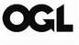
You may re-use this information (excluding logos) free of charge in any format or medium, under the terms of the Open Government Licence v3.0. To view this licence, visit OGL. Where we have identified any third party copyright information you will need to obtain permission from the copyright holders concerned.

