December 2025
A new London-wide partnership is supporting schools to instil healthy childhood habits
At the recent ADPH London Obesity meeting (10 December), we were delighted to welcome colleagues from Camden Public Health, NHS England (London), the Institute for Improvement, North East London ICB and Great Ormond Street Hospital to introduce a new partnership to support healthy habits for primary school children.
The Coalition for Healthy, Happy Childhood formed earlier this year to boost ongoing work to support children in eating more healthily, being more active and minimising personal screen use. It is lead by a Steering group of colleagues from the organisations above, as well as London United and other NHS, local authority and VCSE partners across London.
The coalition has engaged widely with schools, families and partners to develop a demonstration model called Healthier Happier Me to test in 10 London schools. The model (see figure 1) involves establishing a Wellbeing MDT for each school, formed of school leadership; the local football Club Community Organisations; community and public health colleagues and other VSCEs.
A dedicated programme co-ordinator will work with the MDTs to develop or signpost to interventions and offer targeted support to families. They will work from a ‘menu’ of interventions and collect data to support a formal evaluation, to take place this summer, in support of continuous improvement.
For more information on the partnership, including a London-wide learning network, get in touch with the team at: HealthierHappierMe@gosh.nhs.uk
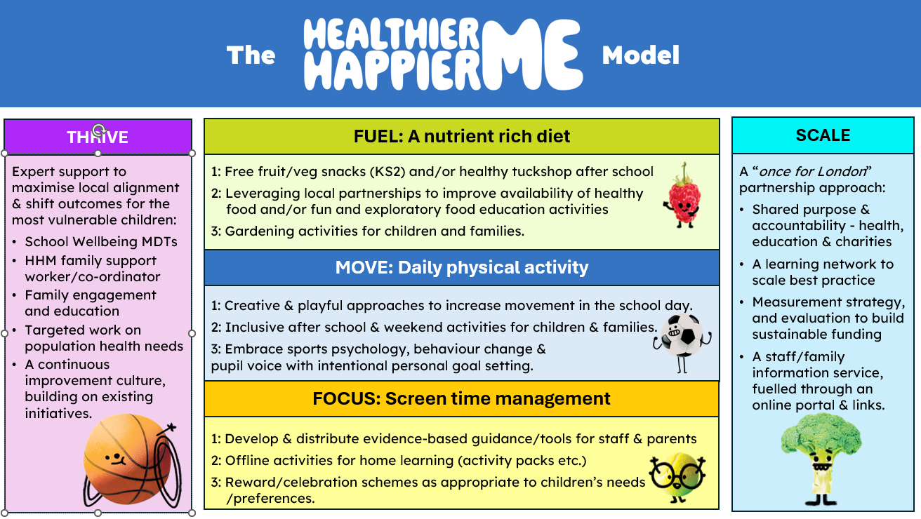

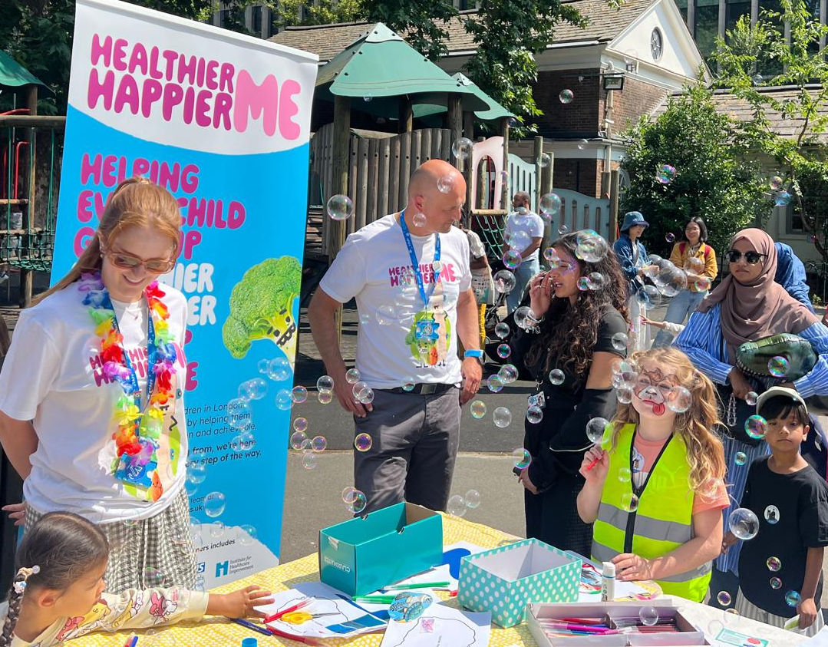
Caption: GOSH CEO Mat Shaw chatting with families about Healthy Habits at a community event in Coram’s Fields



