Centring voices of marginalised communities in London’s crisis response
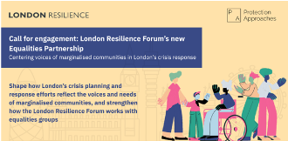
The Greater London Authority is delighted to announce the establishment of a new Equities Partnership within the London Resilience Forum.
This partnership will provide a space for equity-focused and equality-led organisations to shape how London plans for and responds to emergencies and crises in a manner that centres the perspectives and needs of various marginalised communities in London.
Emergencies – from the COVID-19 pandemic to flooding, terror incidents, fire, or the cost-of-living crisis – do not affect all communities equally. People already facing structural inequality often face the greatest harms. The Equalities Partnership will work to ensure that community expertise informs city-wide emergency planning, and that equity organisations are supported as strategic partners in building a more resilient London.
If your group works primarily with marginalised communities, communities who face additional barriers at times of crisis, or individuals with protected characteristics as defined in the Equalities Act, you can feed into what the Equalities Partnership will look like and how it will work.
You can share your perspective with the Protection Approaches team by:
- Responding to this questionnaire
- Scheduling a chat with their team by emailing farida.mostafa@protectionapproaches.org
- Sharing your thoughts via email at farida.mostafa@protectionapproaches.org

