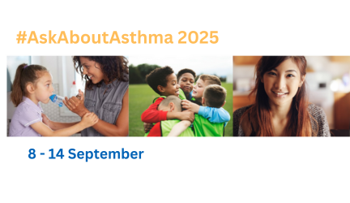
NHS England wish to thank you for your support over the last eight years with NHS England London’s #AskAboutAsthma campaign. #AskAboutAsthma is back this September for its ninth year, and youl are invited to be part of it.
For 2025, the #AskAboutAsthma campaign will run from 8 – 14 September. This year’s theme is ’One year on from the National Child Mortality Database (NCMD) report: Are we getting better at preventing asthma deaths?’
The #AskAboutAsthma campaign encourages children and young people, their families, and those involved in their care, to ensure four simple and effective measures to help them control their asthma:
1. Get an asthma action plan in place
2. Understand how to use inhalerscorrectly
3. Schedule an asthma review – every year and after every attack
4. Consider air pollution and its impact on lung health
This year’s campaign will comprise a half-day virtual conference on Wednesday 10 September and webinars for CYP, families and schools on Monday 8, nursing on Tuesday 9 and primary care on Thursday 11. Registration details will be sent out soon. We will include a rolling slide deck with all your fantastic achievements at the conference. Please send a single slide showcasing your local plans, priorities and achievements in CYP asthma to england.cyptransformationldn@nhs.net.
We would encourage you as always to run a local campaign - please have a look at previous years’ content (podcasts, videos and blogs) to see what might be most relevant to your local priorities – there is so much there and most of it is still up to date and useful.
We will be leaving NHS England London towards the end of July so please direct any queries after then to Rachel Lundy (rachel.lundy@nhs.net) and Stacey Bedford (stacey.bedford@nhs.net) copying in our CYP inboxengland.cyptransformationldn@nhs.net.

