Communications Brief – London HIV Prevention Resident Survey

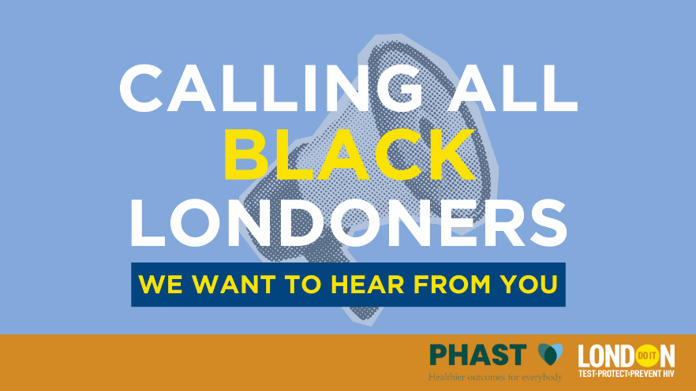

Project Overview
PHAST is a leading public health consultancy with expertise in epidemiology, health economics, health/environmental impact & needs assessments and equity audits.
PHAST has been commissioned by the London HIV Prevention Programme (LHPP)/Do it London to better understand the HIV prevention needs of Black heritage communities in London. As part of this work, we are completing a resident survey to better understand the HIV prevention needs, knowledge, and attitudes of Black heritage communities in London. The insights gathered from this survey will directly shape future services, ensuring they meet the needs of these communities more effectively.
PHAST request the support of local councils, community and voluntary organisations, and public health bodies to promote this survey via social media and other communication channels. Your help in amplifying this message will ensure we reach as many eligible participants as possible.

Target Audience
- A resident of London and/or work or study in London.
- Identify as Black, including Black African, Black Caribbean, or Black British and mixed/multiple ethnic groups.
- 16 years of age or older.

Promotion Strategy
We recommend using the following channels to reach the target audience:
- Websites and newsletters: Promote the survey in newsletters or dedicated sections of websites, especially health and community pages.
- Social Media (Twitter/X, Instagram, Facebook, NextDoor): Leverage social media accounts.
- Community Outreach: Encourage community-based organisations to share the survey in their networks.
Please use any additional channels available.

Suggested Social Media Posts

For Twitter/X:

Post 1: Calling all Black Londoners! Share your thoughts on HIV prevention services in this short survey. Your voice will help shape future services. Have your say in just 10 minutes: [link] #HIVPrevention #BlackHealthMatters #DoitLondon

Post 2: Help shape HIV prevention for Black communities in London! If you’re 16+ and in London, join the survey with @doitldn. Quick, easy—and you could win vouchers up to £100! [link] #HIVAwareness #DoitLondon

For Instagram (with image):

Post 1 (story and bio link): London’s Black communities – your voice is needed! Take this quick survey to share your thoughts on HIV prevention services. Help us make sure future programmes meet your needs. Link in bio to take the survey now!

Post 2 (post): London’s Black communities—your voice matters! Have your say on HIV prevention in just 10 minutes. Complete the survey for a chance to win vouchers up to £100! [link] #HIVPrevention #BlackHealthMatters #DoitLondon

For Facebook/Community Groups:

Post: Help shape HIV services for Black people. If you identify as Black, are over 16, and live, work, or study in London, Do it London wants to hear from you! Your input in this survey will help provide a better understanding of the HIV prevention needs of Black heritage communities in London. The survey only takes 10 minutes, and you could win vouchers up to £100! Take part today: [link] #HIVPrevention #BlackHealthMatters #DoitLondon

Follow-up Social Media Posts
- Post 1: Don’t forget! If you’re a Black Londoner, we want your input on HIV prevention services. The survey only takes 10 minutes, and you could win up to £100 in vouchers! Tap the link in the bio to take part now!
- Post 2: Last chance for you to help shape HIV prevention for Black communities in London! The survey is quick, easy, and you could win vouchers up to £100! Don’t miss out—take the survey now: [link] #HIVAwareness #BlackHealthMatters #DoitLondon
Use the following hashtags when promoting the survey:

#DoitLondon
#HIVPrevention
#HIVAwareness
#BlackHealthMatters

Tag, share and repost.

World AIDS Day Posts
- Use your voice to make a difference this #WorldAIDSDay! If you’re a Black Londoner, share your thoughts on HIV prevention through this quick survey. Your input will help shape HIV prevention services targeting your community. Take 10 minutes today: [link] #HIVPrevention #BlackHealthMatters #DoItLondon

Communications for Council Channels
This should be used for internal communication channels.
Title: Help Shape HIV Prevention Services for your Black Community in London
PHAST are conducting a survey on behalf of the London HIV Prevention Programme (LHPP)/Do it London to better understand the HIV prevention needs, knowledge, and attitudes of Black Londoners. If you identify as Black African, Black Caribbean, or Black British, are over 16, and live, work, or study in London, we want to hear from you!
Your input will directly shape HIV prevention services across London, ensuring they meet the needs of the community. We value the perspectives of Black Londoners from all backgrounds—different faiths, ages, genders, sexual orientations, and cultures. By sharing your views, you help us ensure that services reflect the variety of experiences across London’s Black communities. Take 10 minutes to make a difference today.
Click here to take part: [link]
Footnote: PHAST is a leading public health consultancy with expertise in epidemiology, health economics, health/environmental impact & needs assessments and equity audits. PHAST have been commissioned by the LHPP to complete a needs assessment to understand the HIV prevention needs of Black heritage communities.
Call to Action: Share your voice today and help shape a healthier future for London’s Black communities.

Communications for Newsletters
Help Shape HIV Prevention Services for Black Communities in London
PHAST, on behalf of Do it London, is conducting a survey to better understand the HIV prevention needs, knowledge, and attitudes of Black Londoners. If you identify as Black African, Black Caribbean, or Black British, are over 16, and live, work, or study in London, we want to hear from you!
HIV prevention services are vital for all communities. As we continue to tackle the challenges around HIV prevention, it's essential that services are tailored to the unique needs of different groups. Black communities are disproportionately affected by HIV, and it's crucial that our services reflect the diversity of experiences, attitudes, and cultural contexts within the Black community.
Councillor [Name], [Title], says:
"We need to ensure that HIV prevention services are accessible, relevant, and culturally sensitive. This survey gives Black Londoners the opportunity to share their experiences, helping us to build services that work for everyone in the community."
By taking part, you are helping to ensure that HIV prevention services across London are effective and meet the needs of the Black community. We value the perspectives of Black Londoners from all backgrounds—different faiths, ages, genders, sexual orientations, and cultures. Your views will help us create services that are inclusive and reflective of the variety of lived experiences within the Black community.
Take just 10 minutes to make a difference today.
Click here to take part: [link]
Call to Action:
Share your voice today and help shape a healthier future for London’s Black communities. Your feedback is vital in creating services that truly make a difference.

Key Dates
Survey Link: https://www.surveymonkey.com/r/LondonHIVPreventionResidentSurvey
- Survey launch: 18 November 2024
- Survey close: 9 February 2025

Communications Assets
Link to download Resident Poster
Link to IG graphic 1 Link to X graphic 1
Link to IG graphic 2 Link to X graphic 2
Link to IG graphic 3 Link to X graphic 3
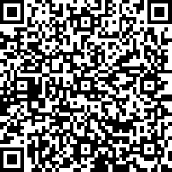
Your help in sharing this survey with your networks is essential in ensuring we reach as many eligible participants as possible. We appreciate your support in making this effort a success!
If you have any questions or need additional information, please contact Alex Wicking at alex.wicking@phast.org.uk.

