NO SMOKING DAY 2024 COMMS TOOLKIT
FROM THE LONDON TOBACCO ALLIANCE

This year marks the 40th anniversary of No Smoking Day (13th March) – a celebration of how far things have come, but a reminder of how far there still is to go to achieve smokefree ambitions.

London Tobacco Alliance is using No Smoking Day as a springboard to launch its campaign:
‘Make Today Your No Smoking Day’

The campaign embraces the nationally recognised day but also provides longevity beyond the 13th March as any day could be a smokers no smoking day.

Every year almost 6,000 Londoners die from smoking related diseases. [1]

This campaign is aimed at reaching as many of the smoking population in London as possible. To make them aware of the real health harms smoking causes and the support available to them to help them stop.
This comms pack includes the following campaign assets for you to use. They can be tailored and shared across your own communication channels and networks to help us reach as many smokers as possible across London.

This pack contains:
- Adaptable poster – amend for local use
- Case study videos – share on websites, intranets etc
- Social short reels, graphics and posts – share on social platforms
- Share your plans – tag us and share your no smoking day plans
- Social live – join us virtually at the national parliamentary event

Guide on how to use campaign assets

Adaptable digital poster
Please use the following link to access a generic digital poster that you can adapt to suit your needs. Simply click on the link and open in Word, you can then add your own logo in the top, right hand corner and add your own copy where lorem ipsum text is displayed, for example highlight a clinic time/location or referral/contact details. It’s a poster that you can tailor to suit your needs and can be shared digitally or printed out and displayed.

If you do not have access to Word, please contact joannam@gardiner-richardson.com and we can send an alternative format.

Case study videos
Everyone’s journey is different and the following videos give expert voices on some of the health harm reasons to quit, help and advice on how to quit and the very personal journey of Liam Mallon.
These videos are available to be downloaded via links below and can be uploaded to your own website to help spread key messages of the campaign. Short reels of the videos are also provided with suggested content for social media channels.

Suggested Text | Video links
What your GP wants you to know about the harms of smoking – Dr Shanika Sharma explains the very real health harms of smoking. | Download video
What are you risking by continuing to smoke? Consultant Vascular Surgeon, Mr Paritosh Sharma explains the real impact of smoking related health harms he sees in his London clinic. | Download video
Everyone’s journey is different. Listen to Liam’s personal story on why and how he quit smoking, with the help of vaping. | Download video
What support is available to help you in your quit journey? Respiratory Pharmacist, Darush Attar explains what options are available to help you stop smoking. | Download video
Expert hints and tips to help you with your quit attempt – Dr Eugenia Lee gives advice on what can help support you in a quit attempt. | Download video

Social short reels, graphics and posts
Share the following social media content about the very real health harms of smoking, why smokers need to stop and what support is out there to help them. All call to actions direct them to the Stop Smoking London campaign page where they can access or be signposted to the right support.

The following tables include pre-written posts supported by a short video clip as well as social media graphics. All of these can be downloaded and shared across your own social platforms.

Suggested Text | Reel links
What your GP wants you to know about the harms of smoking – Dr Shanika Sharma explains the very real health harms of smoking. | Download video
What are you risking by continuing to smoke? Consultant Vascular Surgeon, Mr Paritosh Sharma explains the real impact of smoking related health harms he sees in his London clinic. | Download video
Everyone’s journey is different. Listen to Liam’s personal story on why and how he quit smoking, with the help of vaping. | Download video
What support is available to help you in your quit journey? Respiratory Pharmacist, Darush Attar explains what options are available to help you stop smoking. | Download video
Expert hints and tips to help you with your quit attempt – Dr Eugenia Lee gives advice on what can help support you in a quit attempt. | Download video

Social media post and graphics
Suggested Text | Social Media Graphic
Smoking related health harms are real.  Make today your no smoking day and get the support you need to help you through your quit journey.  https://stopsmokinglondon.com/make-today-your-no-smoking-day/  #MakeTodayYourNoSmokingDay | 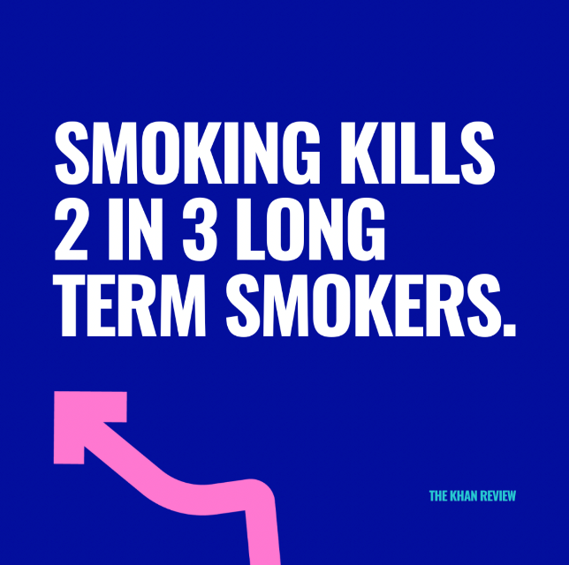  Download graphic
What happens to my body when I stop smoking?  As soon as you stop smoking you and your body will experience both short and long term health benefits.  https://stopsmokinglondon.com/why-quit-smoking/benefits-of-quitting-smoking/  https://stopsmokinglondon.com/make-today-your-no-smoking-day/  #MakeTodayYourNoSmokingDay | Download graphic
We know quitting smoking can be difficult and that everyone’s journey is different.  Stop Smoking London is here to help with a number of different support services so you can choose the right one for you.  https://stopsmokinglondon.com/make-today-your-no-smoking-day/  #MakeTodayYourNoSmokingDay | Download graphic
Take that first step and start your quit journey now. We are here to help you.  https://stopsmokinglondon.com/make-today-your-no-smoking-day/  #MakeTodayYourNoSmokingDay | Download graphic

Share your plans
In addition, to sharing the provided campaign assets across the London Tobacco network, we’d like to share local news, plans, case studies around No Smoking Day that are happening across the London boroughs. Please tag @StopSmokingLDNand @LTA_London when sharing local news or if you’d like to send in any details to londontobaccoalliance@towerhamlets.gov.uk we can include details on the London Tobacco Alliance and Stop Smoking London websites and social channels.

National picture
In recognition of national No Smoking Day, OHID will be launching a wider campaign around the health harms from smoking. There will be national campaign resources available nearer the time https://campaignresources.dhsc.gov.uk/campaigns/

In addition, ASH and the APPG on Smoking and Health are holding a Smoking Survivors drop-in event in Parliament on No Smoking Day itself. The event will bring together people whose lives have been impacted by smoking and young people who will benefit from the Government’s smokefree generation legislation. It will be an opportunity for MPs to meet local people and hear about why raising the age of sale and creating a smokefree generation matters to them.

Social Live
London Tobacco Alliance will be in attendance at the parliamentary event and we’ll be keeping our network up to date via our London Tobacco Alliance channels. Feel free to join us virtually and share the posts as the afternoon unfolds.

References
[1] Economic and health inequalities dashboard - ASH

[2] Stopping the start: our new plan to create a smokefree generation - GOV.UK (www.gov.uk)

