Phase 2 polio and MMR campaign May 2023
Introduction
This toolkit is designed to accompany the launch of the phase 2 polio/MMR campaign and its ongoing promotion. Resources include:
- Posters (x4 – one for each of polio, measles, mumps and rubella)
- Social media assets (4x square, 4x landscape)
- Landing page: www.transformationpartnersinhealthandcare.nhs.uk/london-polio-mmr (includes FAQs)
Further resources will be added over the coming weeks and months. You can find the assets on FutureNHS and Google Drive
Other related useful assets:

British Society for Immunology vaccine animation
This animation was co-produced with the British Society for Immunology to help parents and carers in making informed decisions about consent or when discussing routine vaccinations with their families and children and young people. View on YouTube

NHS vaccinations for children playlist (NHS Digital)
In this seven video series, Dr Kiran Rahim explains more about vaccinations for children. The videos cover:
- Why you should get your child vaccinated
- Types of vaccines for children
- Why your child needs more than one vaccine dose
- Does my child need the polio vaccine?
- Are measles, mumps, and rubella (MMR) serious in children?
- Is the MMR vaccine safe for children?
- How to check your child’s vaccination record
You can also follow and repost us at on Instagram, Twitter and Facebook.
Key messages
Condition specific messaging:
- Polio is a serious virus that can cause paralysis or even death. There is no cure for polio. Vaccination is the only protection.
- Measles spreads easily and can cause serious illnesses including pneumonia and meningitis.
- Mumps spreads easily and in rare cases can cause serious illnesses including meningitis. There is no cure for mumps. Vaccination is the only protection.
- Rubella can make your child feel very unwell and if they come into contact with someone who is pregnant, there can be complications for the unborn baby. There is no cure for rubella. Vaccination is the only protection.
The vaccinations:
- The best way to protect your child is to make sure they are fully up to date with vaccinations.
- These vaccines will increase your child’s protection and have been safely given to millions of children.
- The vaccine(s) your child is offered will be the right one for their age. Please check their red book or visit nhs.uk/childvaccines for more information.
The London-programme phase 2:
- London has lower rates of childhood vaccination than other regions in England and this was made worse by the pandemic when many children missed their vaccinations.
- Parents and carers of children aged one to 11 who are not up to date with their vaccinations, will be offered vaccinations against polio and measles, mumps and rubella (MMR) through primary schools, community venues and GPs.
- If your child has missed a polio or MMR vaccine, the local NHS will contact you to discuss what’s available in your area, or you can contact your GP.
  - If your child is 4-11, a registered healthcare professional will contact you to talk you through the local offer, explain the consent process, answer any questions and arrange an appointment.
  - If your child is aged 1-4, check your child’s red book and contact your GP to book an appointment for any missed vaccinations.
- Adults and children of any age can contact their GP to book missed vaccinations at any time.
News article
Children in London offered polio and MMR vaccinations through primary schools
From May 2023, parents and guardians of children aged one to 11, who are not up to date with their vaccinations, will be offered vaccinations for their children against polio and measles, mumps and rubella (MMR) through primary schools and community venues. They can also contact their GP surgery at any time to get their children up to date with their vaccinations.
Polio and measles currently pose a particular threat to the capital. Polio is a serious virus that can cause paralysis or even death. There is no cure for polio; vaccination is the only protection. In 2022, we found traces of the polio virus in sewage samples in London, suggesting that the virus has been spreading between people. While the recent booster programme in late 2022 was successful in giving booster doses to around 345,000 children, far fewer of those who were behind on their vaccination schedule came forward, leaving many without full protection. Those who have not been fully vaccinated could be at risk of catching polio.
There has also been a rise in measles cases in London this year, with 33 confirmed cases reported between 1 January and 20 April 2023 alone.
London has significantly lower rates of routine childhood vaccinations than other regions and this was made worse by the pandemic.
Parents of primary school aged children who may have missed a vaccine will be contacted by the NHS through their school age immunisation service (SAIS) provider. A registered healthcare professional will be able to talk them through the local offer, explain the consent process, answer any questions and arrange an appointment. Alternatively, parents can check their child’s red book and contact their GP to book an appointment for any missed vaccinations. Parents of children aged 1-4 should also contact their GP.

Chief nurse for the NHS in London Jane Clegg said: “We all want to keep children safe and protected from serious illness, which is why we’re doing everything we can to support parents across London to ensure their children are up to date with their vaccinations, especially polio and MMR. These vaccines will increase children’s protection and have been safely given to millions of children.”
[372 words]

Social media content:
Date | Platform | Copy | Image
From 16/05/2023 | Facebook  Instagram | Vaccination is the only protection from polio.  Polio vaccines are now being offered through primary schools and community venues for children in London who are not up to date.  If your child has missed a polio or MMR (measles, mumps and rubella) vaccine, we will contact you. Don’t delay when you’re contacted.  Find out more:  www.transformationpartnersinhealthandcare.nhs.uk/london-polio-mmr | 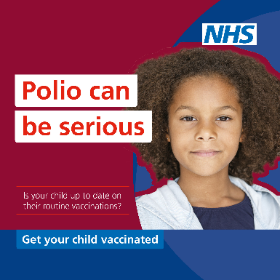
 | Facebook  Instagram | London children aged 4-11 who are not up to date on their vaccinations can now get protected from polio and MMR (measles, mumps and rubella) through primary schools and community venues.  Find out more:  www.transformationpartnersinhealthandcare.nhs.uk/london-polio-mmr | [Any 1:1 asset]
 | Facebook  Instagram | Cases of measles are rising in London. Protect your child by making sure they are up to date with their MMR (measles, mumps and rubella) vaccinations.  Check your child’s red book and contact your GP to book an appointment for any missed vaccinations.  MMR and polio vaccines are now also being offered through primary schools and community venues for London children who are not up to date.  Find out more:  www.transformationpartnersinhealthandcare.nhs.uk/london-polio-mmr | 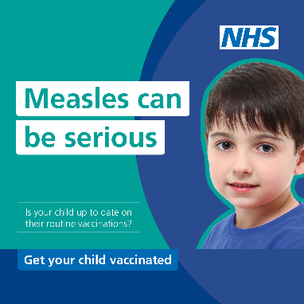
 | Facebook  Instagram | If your child is overdue an MMR (measles, mumps and rubella) or polio vaccine, it’s not too late to get them protected.  MMR and polio vaccines are now being offered to London children through primary schools and community venues. If your child has missed a dose, we will contact you. Don’t delay when you’re contacted.  For more information, visit: www.transformationpartnersinhealthandcare.nhs.uk/london-polio-mmr | 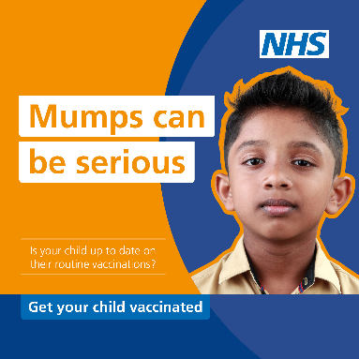
 | Twitter | Has your child missed an MMR (measles, mumps and rubella) vaccination?  London children can get protected through primary schools and community venues. If your child has missed a dose, we will contact you. Don’t delay when you’re contacted.  www.transformationpartnersinhealthandcare.nhs.uk/london-polio-mmr  [265] | 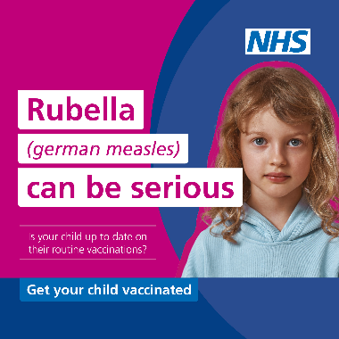
 | Twitter | Londoners, is your child up to date on their polio vaccinations?  If your child has missed a dose, we will contact you to organise an appointment through a primary school or community venue. Don’t delay when you’re contacted.  Find out more:  www.transformationpartnersinhealthandcare.nhs.uk/london-polio-mmr  [266] | 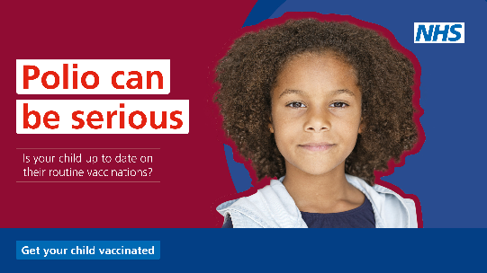
 | Twitter | London parents, it's important to vaccinate children against MMR to prevent serious illness.  If your child has missed a dose, we will contact you to organise an appointment through a primary school or community venue. Don’t delay when you’re contacted.  www.transformationpartnersinhealthandcare.nhs.uk/london-polio-mmr  [279] | 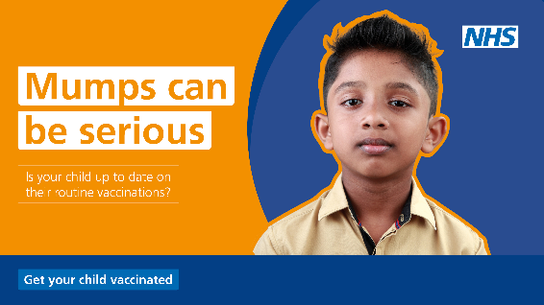
 | Twitter | Measles cases are rising in London. Make sure your child is protected with an MMR (measles, mumps and rubella) vaccination.  Check your child’s red book and contact your GP to book an appointment for any missed vaccinations.  Find out more: www.transformationpartnersinhealthandcare.nhs.uk/london-polio-mmr  [226] | 