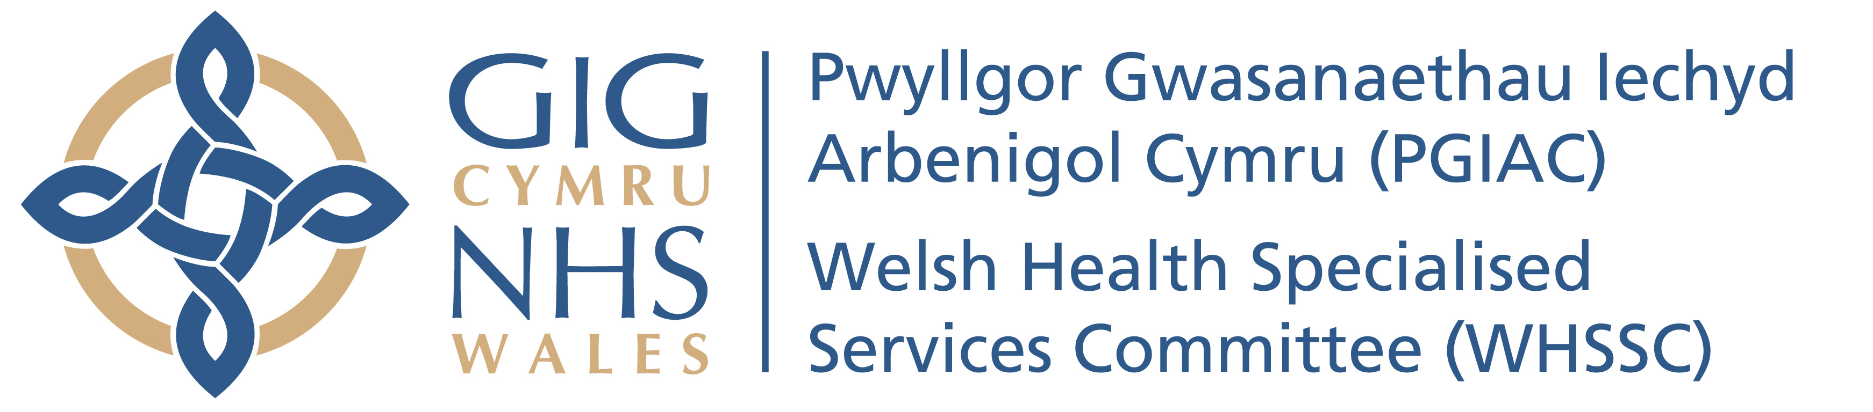 | Your ref/eich cyf:
 | Our ref/ein cyf:
 | Date/dyddiad: | 19 June 2014
 | Tel/ffôn: | 01443 443443 ext 8100
 | Fax/ffacs: | 02920 807 854
 | Email/ebost:

Dear Director of Public Health

I would be grateful if you could complete this simple one side of A4 questionnaire (overleaf) and return it to me by post, fax or email.

It relates to gauging current awareness of End of Life care amongst Directors of Public Health. Bearing in mind the aging population, End of Life care is the most costly part of health care provision and rapidly rising. In addition, End of Life care has an enormous impact on health & well being of carers, as well as direct impact on social services provision.

The reason for undertaking this audit is to understand more about the perception of End of Life care is amongst DsPH and to feed back the results via a written paper or presentation at a conference.

I would like to stress that End of Life care is broader than palliative care. Palliative care is often seen as a specialist area of interest associated with Hospices and Community Palliative Care teams. Specialist palliative care does not cover nursing homes (including dementia providers), community nursing teams etc.

I realize that you do not have much time to complete these but would appreciate a response to help paint a picture of the current status of this issue across the country.

Yours gratefully

Dr Khesh Sidhu
Deputy Medical Director

Khesh.sidhu@wales.nhs.uk

Question | Please circle the relevant response
Do you have a consultant or specialist in your team who’s job plan specifically includes End of Life? | Yes / No / Not sure
Has there been a needs assessment of End of Life Care or Palliative care in the last 5 years? | Yes / No / Not sure
How important do you think End of Life service provision is for the future shaping of services in your area? | Important  no particular view  Not important
Is it the DsPH role to help shape this debate in your locality? | Yes / No / Not sure
Where do you work? | England / Scotland / Wales / Northern Ireland

Please forward your completed questionnaire to

Dr K Sidhu
Welsh Health Specialised Services Team,
Unit 3a,
Caerphilly Business Park
Van Road,
Caerphilly
CF83 3ED.

Or email it to khesh.sidhu@wales.nhs.uk
Or fax to 02920 807 854

